**CHAPTER 1**

**INTRODUCTION**

**1.1 Overview**

The mini project entitled **Food Ordering Dashboard** incorporates as many features of a simple web application as possible in addition with a few of our own functions using the skills that have been learnt in class. Here, an attractive front-end and various other functionalities have been created using the knowledge of HTML, JavaScript, PHP and CSS and an efficient back-end is designed using the knowledge of MySQL, allowing the user to order food in the online portal. The target is to computerize and automate the manual management of food delivery agents

**1.2 Problem Statement**

To computerize the existing manual system, this will ease the effort for the food delivery agents. To simplify the process of ordering food from anywhere and not go searching for them. To help restaurants reach a wider network of customers while providing them a platform to advertise their food items. To provide safe transactions between the restaurant and the user.

To provide a good, an attractive and easy to use user interface and an efficient database management system which can maintain the data to be stored for the Food Ordering Dashboard.

**1.3 Web Technologies**

Web technology refers to the means by which computers communicate with each other using mark-up languages and multimedia packages. It gives us a way to interact with hosted information, like websites. Web technology involves the use of hypertext mark-up language (HTML) and cascading style sheets (CSS). There are many other technologies that are available that helps us to create website best suited for our needs. We will learn more about these technologies in the following sub sections.

**1.3.1 HTML5**

HTML5 is a mark-up language used for structuring and presenting content on the World

Wide Web. It is the fifth and current major version of the HTML standard.

It was published in October 2014 by the World Wide Web Consortium (W3C) to improve the language with support for the latest multimedia, while keeping it both easily readable by humans and consistently understood by computers and devices such as web browsers, parsers, etc. HTML5 is intended to subsume not only HTML 4, but also XHTML 1 and DOM Level 2 HTML.

HTML5 includes detailed processing models to encourage more interoperable implementations; it extends, improves and rationalizes the mark-up available for documents, and introduces mark-up and application programming interfaces (APIs) for complex web applications. For the same reasons, HTML5 is also a candidate for cross- platform mobile applications, because it includes features designed with low-powered devices in mind [1].

The figure: 1.1 shows the overall architectural view of HTML5.

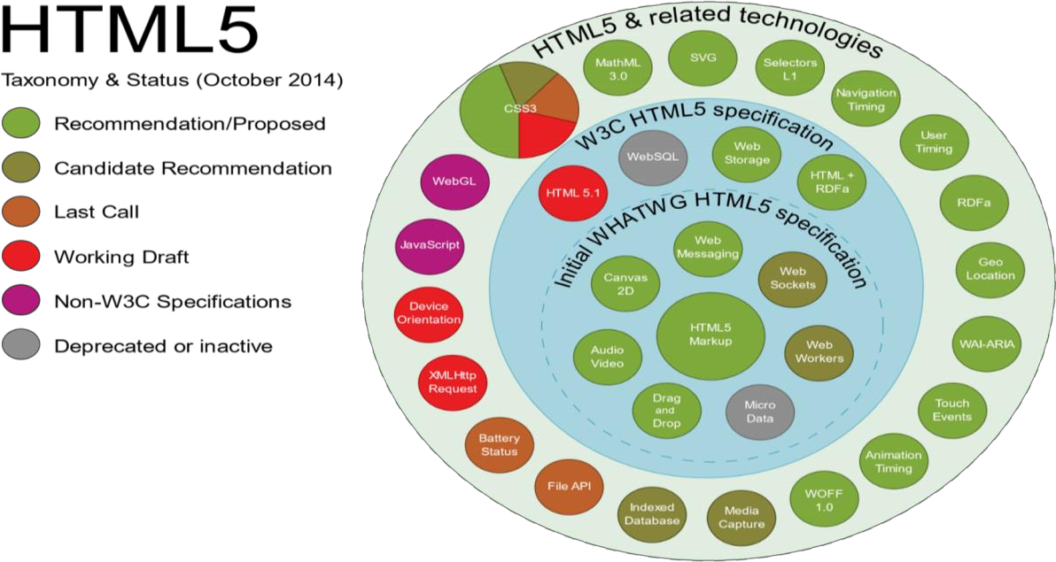

**Fig. 1.1:** HTML5 APIs and related technologies taxonomy and status

**1.3.2 CSS**

Cascading Style Sheets (CSS) is a style sheet language used for describing the presentation of a document written in a markup language like HTML.CSS is a cornerstone technology of the World Wide Web, alongside HTML and JavaScript.

CSS was first proposed by HåkonWium Lie on October 10, 1994. At the time, Lie was working with Tim Berners-Lee at CERN.Several other style sheet languages for the web were proposed around the same time, and discussions on public mailing lists and inside World Wide Web Consortium resulted in the first W3C CSS Recommendation (CSS1) being released in 1996. In particular, Bert Bos' proposal was influential; he became co- author of CSS1 and is regarded as co-creator of CSS.

Style sheets have existed in one form or another since the beginnings of Standard Generalized Markup Language (SGML) in the 1980s, and CSS was developed to provide style sheets for the web. One requirement for a web style sheet language was for style sheets to come from different sources on the web. Therefore, existing style sheet languages like DSSSL and FOSI were not suitable. CSS, on the other hand, let a document's style be influenced by multiple style sheets by way of "cascading" styles.

CSS is designed to enable the separation of presentation and content, including layout, colours, and fonts. This separation can improve content accessibility, provide more flexibility and control in the specification of presentation characteristics, enable multiple web pages to share formatting by specifying the relevant CSS in a separate .css file, and reduce complexity and repetition in the structural content.

Separation of formatting and content also makes it feasible to present the same mark-up page in different styles for different rendering methods, such as on-screen, in print, by voice (via speech-based browser or screen reader), and on Braille-based tactile devices. CSS also has rules for alternate formatting if the content is accessed on a mobile device.

The name[2] *cascading* comes from the specified priority scheme to determine which style rule applies if more than one rule matches a particular element. This cascading priority scheme is predictable.

Some of the notable advantages are as follows:

➢ Separation of content from presentation

CSS facilitates publication of content in multiple presentation formats based on nominal parameters. Nominal parameters include explicit user preferences, different web browsers, the type of device being used to view the content (a desktop computer or mobile Internet device), the geographic location of the user and many other variables.

➢ Site-wide consistency

When CSS is used effectively, in terms of inheritance and "cascading", a global style sheet can be used to affect and style elements site-wide. If the situation arises that the styling of the elements should be changed or adjusted, these changes can be made by editing rules in the global style sheet. Before CSS, this sort of maintenance was more difficult, expensive and time-consuming.

➢ Bandwidth

A stylesheet, internal or external, specifies the style once for a range of HTML elements selected by „class‟ type or relationship to others. This is much more efficient than repeating style information inline for each occurrence of the element. An external stylesheet is usually stored in the [browser cache, and can therefore be used on](https://en.wikipedia.org/wiki/Browser_cache) multiple pages without being reloaded, further reducing data transfer over a network.

➢ Page reformatting

With a simple change of one line, a different style sheet can be used for the same page. This has advantages for accessibility, as well as providing the ability to tailor a page or site to different target devices. Furthermore, devices not able to understand the styling still display the content.

➢ Accessibility

Without CSS, web designers must typically lay out their pages with techniques such as HTML tables that hinder accessibility for vision-impaired users.

The figure:1.2 shows the architectural view of CSS

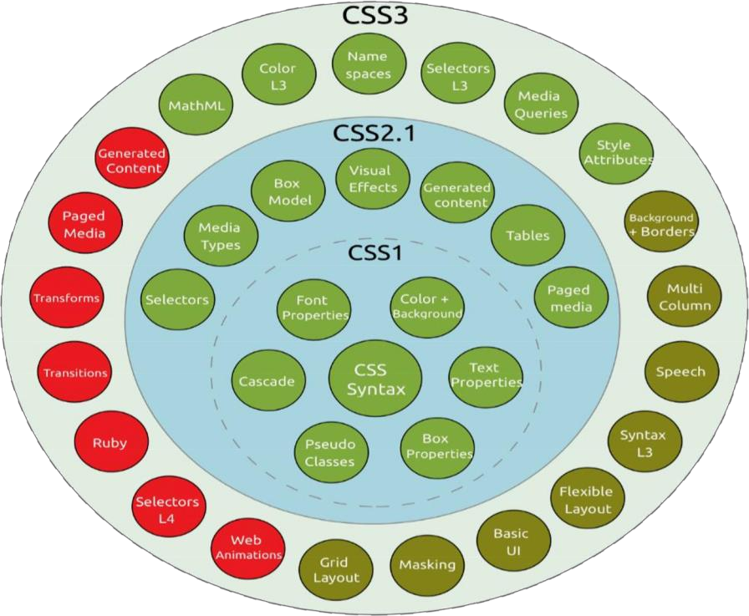

● Recommendation ● Candidate Recommendation ● Last Call

● Working Draft.

**Fig. 1.2** Taxonomy and status of CSS3 modules

**1.3.3 JavaScript**

JavaScript, often abbreviated as JS, is a high-level, interpreted programming language. It is a language which is also characterized as dynamic, weakly typed, prototype-based and multi-paradigm.

Alongside HTML and CSS, JavaScript is one of the three core technologies of the World Wide Web. JavaScript enables interactive web pages and thus is an essential part of web applications. The vast majority of websites use it, and all major web browsers have a dedicated JavaScript engine to execute it.

As a multi-paradigm language, JavaScript supports event-driven, functional, and imperative (including object-oriented and prototype-based) programming styles. It has an API for working with text, arrays, dates, regular expressions, and basic manipulation of the DOM, but the language itself does not include any I/O, such as networking, storage, or graphics facilities, relying for these upon the host environment in which it is embedded.

Initially only implemented client-side in web browsers, JavaScript engines are now embedded in many other types of host software, including server-side in web servers and databases, and in non-web programs such as word processors and PDF software, and in runtime environments that make JavaScript available for writing mobile and desktop applications, including desktop widgets [2].

Some of the notable advantages are as follows:

➢ Speed

Being client-side, JavaScript is very fast because any code functions can be run immediately instead of having to contact the server and wait for an answer.

➢ Simplicity

JavaScript is relatively simple to learn and implement.

➢ Versatility

JavaScript plays nicely with other languages and can be used in a huge variety of applications. Unlike PHP or SSI scripts, JavaScript can be inserted into any web page regardless of the file extension. JavaScript can also be used inside scripts written in other languages such as Perl and PHP.

➢ Server Load

Being client-side reduces the demand on the website server.

**1.3.4 PHP**

PHP: Hypertext Preprocessor (or simply PHP) is a server-side scripting language designed for Web development, and also used as a general-purpose programming language. It was originally created by Rasmus Lerdorf in 1994, the PHP reference implementation is now produced by The PHP Group. PHP originally stood for Personal Home Page, but it now stands for the recursive initialism PHP: Hypertext Preprocessor. PHP code may be embedded into HTML code, or it can be used in combination with various web template systems, web content management systems, and web frameworks. PHP code is usually processed by a PHP interpreter implemented as a module in the web server or as a Common Gateway Interface (CGI) executable. The web server combines the results of the interpreted and executed PHP code, which may be any type of data, including images, with the generated web page. PHP code may also be executed with a command-line interface (CLI) and can be used to implement standalone graphical applications.

The standard PHP interpreter, powered by the Zend Engine, is free software released under the PHP License. PHP has been widely ported and can be deployed on most web servers on almost every operating system and platform, free of charge [3].

The reason behind the popularity of PHP is its several advantages. PHP is most suited for the purpose of web development. The advantages of PHP are discussed briefly below:

➢ Cross Platform :

All the PHP based applications can run on various types of platforms. PHP is supported by majority of Operating Systems, some of which includes Solaris, UNIX, Windows and Linux. The mentioned platforms can be used to write codes in PHP and also view web pages or run the PHP based applications.

PHP easily interfaces with MySQL and Apache both. An effortless integration of PHP can be done with various other technologies like Java and there is no requirement of redevelopment. Therefore, saving both time and money, giving it an important advantage.

➢ Easy database connection :

A programming language like PHP is widely used on the internet and needs to connect to the database very often. Therefore, having a feature that could help PHP to connect to database easily is mandatory. Several websites such as the ecommerce websites, require good database management system.

PHP has a built-in module that helps it in connecting with database easily. Therefore, PHP has a great demand in the field of web development where a data driven website needs to be developed. PHP significantly reduces the time needed in developing the web application that needs an efficient database management system.

➢ Easy to use :

PHP is widely used because it is easy to use. In contrast with other programming languages that are complex, PHP is simple, fluent, clean and organized, hence it is a boon for the new users. PHP has a well-organized syntax which is logical at the same time.

PHP does not require any intensive studying or manual to use it. Command functions of PHP are easily understood as the user can easily figure out from the name of the commands itself what it does. A person who is new to PHP can still code because the syntax is somewhat similar to C.

A person who is new to PHP can still code because the syntax is somewhat similar to C. Hence, if a person who knows C can easily code in PHP. Hence, it is easier to create and optimize the application using PHP.

Speed is the primary need of web development. There are people who face the challenge of slow internet connection and slow data speed. Furthermore, a fast loading website is always preferred by people across the globe. When compared to other programming languages, PHP is found to be the fastest programming language.

In normal circumstances, it takes a lot of time to connect to the database, when you attempt to fetch certain data from the database. It takes a lot of time in connecting to the database, then executing the statement and finally getting the data. PHP performs these set of tasks faster than other scripting languages. PHP is faster in both connecting to the database and in using other important applications.

The high speed of PHP gives it an advantage over other scripting languages and gives it an application in important administrations such as the server administration and mail functionalities.

➢ Open source :

One of the important advantages of PHP is that it is Open Source. Therefore, PHP is readily available and is entirely free. In contrast to other scripting languages used for web development which requires the user to pay for the support files, PHP is open to everyone, anytime and anywhere. A beginner in PHP need not worry about the support as PHP is maintained and developed by a large group of PHP developers which helps in creating support community of PHP that helps people in PHP implementation and manipulation.

**1.4 Database Management System**

A database management system (DBMS) is system software for creating and managing databases. The DBMS provides users and programmers with a systematic way to create, retrieve, update and manage data.

A DBMS makes it possible for end users to create, read, update and delete data in a database. The DBMS essentially serves as an interface between the database and end users or application programs, ensuring that data is consistently organized and remains easily accessible.

The DBMS manages three important things: the data, the database engine that allows data to be accessed, locked and modified -- and the database schema, which defines the database‟s logical structure. These three foundational elements help provide concurrency, security, data integrity and uniform administration procedures. Typical database administration tasks supported by the DBMS includechange management, performance monitoring/tuning and backup and recovery. Many database management systems are also responsible for automated rollbacks, restarts and recovery as well as the logging and auditing of activity.

**1.4.1 Advantages of DBMS**

Central storage and management of data within the DBMS provides:

1. Data abstraction and independence

2. Data security

3. A locking mechanism for concurrent access

4. An efficient handler to balance the needs of multiple applications using the same data

5. The ability to swiftly recover from crashes and errors, including restartability and recoverability

6. Robust data integrity capabilities

7. Logging and auditing of activity

8. Simple access using a standard application programming interface (API)

**1.5 SQL**

SQL (Structured Query Language) is a domain-specific language used in programming and designed for managing data held in a relational database management system (RDBMS). SQL offers two main advantages: first, it introduced the concept of accessing many records with one single command; and second, it eliminates the need to specify how to reach a record, e.g. with or without an index.

Originally based upon relational algebra and tuple relational calculus, SQL consists of a data definition language, data manipulation language, and data control language. The scope of SQL includes data insert, query, update and delete, schema creation and modification, and data access control.

SQL became a standard of the American National Standards Institute (ANSI) in 1986, and of the International Organization for Standardization (ISO) in 1987.Since then, the standard has been revised to include a larger set of features. Despite the existence of such standards, most SQL code is not completely portable among different database systems without adjustments.

**Chapter 2**

**RESOURCE REQUIREMENTS**

A software requirement definition is an abstract description of the services which the system should provide and the constraints under which the system must operate. It should only specify the external behaviour of the system.

**2.1 Functional Requirements**

Functional Requirements defines the internal working of the software, i.e., the calculations, technical details, data manipulation and processing and other specific functionality that show how the cases are to be satisfied and how they are supported by non-functional requirements, which impose constraints on the design or the implementation.

The following are the Functional requirements:

• The ability to perform the correct operation when the corresponding functions are called.

• When the function is called, the corresponding actions should be performed.

• The ability to store the data in the database when the input is fed from the front- end.

**2.2 Non-Functional Requirements**

Nonfunctional requirements are requirements which specify criteria that can be used to judge the operation of the system, rather than specific behaviours. This should be contrasted with functional requirements that specify specific behaviour or functions. Typical nonfunctional requirements are reliability and scalability. Nonfunctional requirements are “constraints”, “quality attributes” and “quality of service requirements”.

**2.3 Software and Hardware Requirements**

**Software Requirements**

1. OPERATING SYSTEM : Windows XP or Higher version

2. FRONT END : HTML,CSS,Jquery,Bootstrap

3. BACK END : MySql, PHP, JavaScript,XAMPP

**Hardware Requirements**

1. SYSTEM : Pentium IV 2.4 GHz

2. HARD DISK : 20 GB

3. MONITOR : 15 VGA color

4. RAM : 512 MB

**2.4 Technology Stack**

➢ HTML provides a means to structure text based information in a document. It allows users to produce web pages that include text, graphics and hyperlinks.

➢ JavaScript is a scripting language which supports the development of both client and server applications. It is preferred at client side to write programs that can be executed by a web browser within the context of a web page.

➢ CSS (Cascading Style Sheets) is a style sheet language used for describing the presentation of a document written in a mark-up language.

➢ SQL is the language used to manipulate relational databases. It is tied closely with the relational model. It is issued for the purpose of data definition and data manipulation.

➢ PHP: Hypertext Pre-processor (or simply PHP) is a server-side scripting language designed for Web development, and also used as a general-purpose programming language.

**CHAPTER 3**

**DETAILED DESIGN**

**3.1 System Design**

PHP is written as standard text files with the .php extension. PHP files are often saved within a folder in a web server's public directory (or a web root directory). On most systems this will either be named public or public_html. For example, if a file was saved as index.php in a web root directory, a user could access it by typing http://www.example.org or http://www.example.org/index.php.

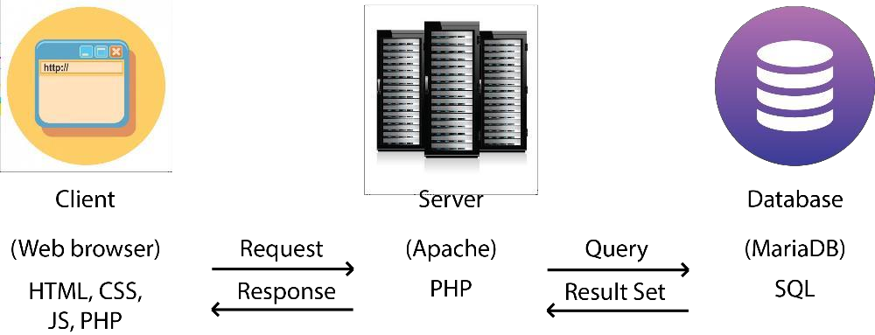

**Fig. 3.1:** Food Ordering Dashboard Architecture

So what exactly is happening when a user types in the URL http://example.org? When a user types in http://example.org in a Web client (a browser, for instance), the client issues a GET request to the server (let's assume that we are both using Apache). When Apache gets this request, it looks for a file named index.php (or index.html, remember the directory indexes from earlier?). If a file named index.php is found, Apache essentially says "Hey, this is a PHP file because it has the .php extension. I am going to give this to the PHP interpreter" as shown in Fig. 3.1.

After Apache decides that is a PHP file, it gives it to the PHP interpreter. When PHP receives the file it reads through it and executes any PHP code it can find. After it is done with the file, the PHP interpreter gives the output of the code, if any, back to Apache. When Apache gets the output back from PHP, it sends that output back to a browser which renders it to the screen.

**3.2 Entity Relationship Diagram**

An entity–relationship model is usually the result of systematic analysis to define and describe what is important to process in an area of a business.

An E-R model does not define the business processes; it only presents a business data schema in graphical form. It is usually drawn in a graphical form as boxes (entities) that are connected by lines (relationships) which express the associations and dependencies between entities.

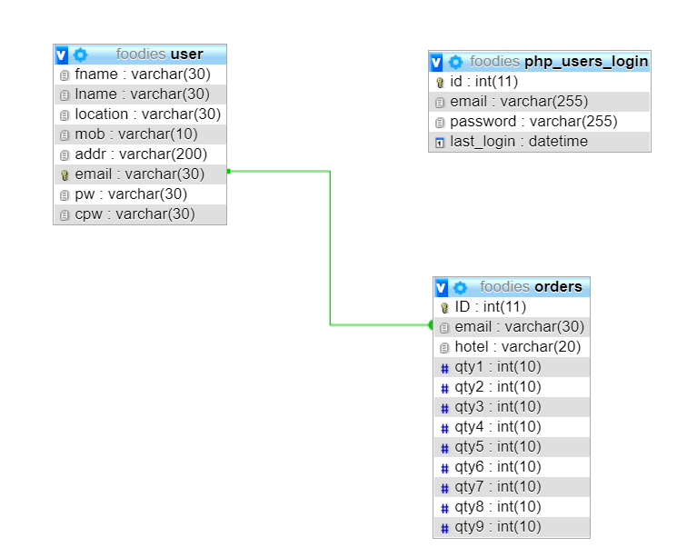Entities may be characterized not only by relationships, but also by additional properties (attributes), which include identifiers called "primary keys". Diagrams created to represent attributes as well as entities and relationships may be called entity-attribute- relationship diagrams, rather than entity-relationship models shown in the Fig 3.2.

**Fig 3.2:** ER Diagram for the Food Ordering Dashboard Database.

**3.3 Flow Diagram**

A data flow diagram is a graphical representation of the "flow" of data through an information system, modelling its process aspects as shown in the Fig. 3.3.

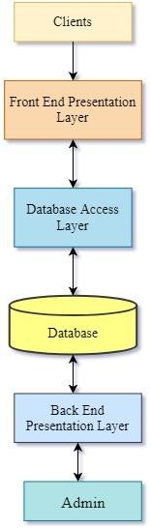

**Fig 3.3:** Flow Diagram for Food Ordering Dashboard

• **Clients :**

Clients are desktop computer or workstation that is capable of obtaining information and applications from a server.

• **Front End Presentation Layer :**

Front end consists of web designing and front-end web development. Html, CSS, JavaScript or jQuery are mainly used for front end development.

• **Database Access Layer :**

Database Access Layer is a [layer of a](https://en.wikipedia.org/wiki/Layer_(object-oriented_design)) [computer program which provides](https://en.wikipedia.org/wiki/Computer_program) simplified access to [data stored in](https://en.wikipedia.org/wiki/Data) [persistent storage of some kind, such as](https://en.wikipedia.org/wiki/Persistent_storage) an [entity-relational database.](https://en.wikipedia.org/wiki/Database)

• **Database :**

A database is an organized collection of [data, generally stored and](https://en.wikipedia.org/wiki/Data_(computing)) accessed electronically from a computer system. Where databases are more complex, they are often developed using formal [design and modelling techniques.](https://en.wikipedia.org/wiki/Database#Design_and_modeling)

• **Back End Presentation Layer :**

Back end consists of database designing and back-end development. SQL

is mainly used for back end development.

• **Admin :**

Admin monitors the activities involved in managing or organizing a business or an organization.

**3.4 Description of Tables**

**Orders Table:**

This table contains the information of all the orders made.

**Table 3.1: Orders Table**

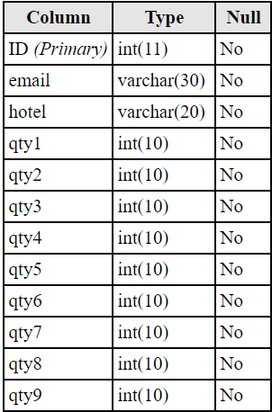

**Users Table:**

This table contains all the information of the users.

**Table 3.2: Users Table**

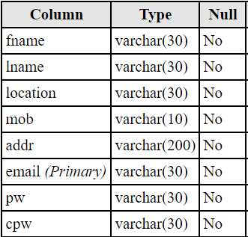

**Login Table:**

This table contains the login information of the registered users.

**Table 3.3: Login Table**

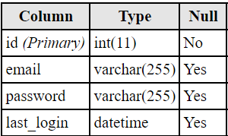

**CHAPTER 4**

**IMPLEMENTATION**

**4.1 MODULES AND THEIR ROLES**

The project contains the following modules which are integrated together:

**1. Register Module:**

This module helps a new user to register with the website and create his login credentials. One can register himself by providing his full name, email-id, contact number, preferred address of delivery and password. The below code gives the details of the same:

if (isset($_POST['submit']))

{

$fname=$_POST['fname'];

$lname=$_POST['lname'];

$location=$_POST['location'];

$mob=$_POST['mob'];

$addr=$_POST['addr'];

$email=$_POST['email'];

$pw=$_POST['pw'];

$cpw=$_POST['cpw'];

$sql = "INSERT INTO user VALUES ('$fname', '$lname', '$location', '$mob', '$addr',

'$email', '$pw', '$cpw');";

if(mysqli_query($conn, $sql))

{

$message = "You have been successfully registered";

$sql1 = "INSERT INTO php_users_login(`email`, `password`) VALUES ('$email',

'$pw');";

if(mysqli_query($conn, $sql1))

{

$message1 = "Added in login table";

}

else

{

$message1 = "Could not insert record";

}

echo "<script type='text/javascript'>alert('$message');</script>";

}

else

{

echo "<script type='text/javascript'>alert('User already Exists!');</script>";

}

**2. Login Module**

This module allows a registered user to login using his email-id and password. After entering into his account, he can be able to view the available hotels and their respective menus from which he can order food. The below code gives the details of the same:

if(isset($_POST['is_login']))

{

$em = mysqli_real_escape_string($connection, $_POST['email']);

$ps = mysqli_real_escape_string($connection, $_POST['password']);

$sql_result = mysqli_query($connection, "SELECT * FROM user where email = '$em' and

pw = '$ps'") or die ('request "Could not execute SQL query" '.$sql);

if(mysqli_num_rows($sql_result)>0){

$user = mysqli_fetch_assoc($sql_result);

$_SESSION['user_info'] = $user['email'];

$_SESSION['first_name'] = $user['fname'];

$_SESSION['last_name'] = $user['lname'];

$_SESSION['addr'] = $user['addr'];

$_SESSION['mob'] = $user['mob'];

mysqli_free_result($sql_result);

}

else{

$error = 'Wrong email or password.';

echo"$error";

}

mysqli_close($connection);

}

if(isset($_GET['ac']) && $_GET['ac'] == 'logout'){

session_unset();

session_destroy();

$red = 'index.php';

echo"<script>window.location.href='$red'</script>";

}

**3. User Profile**

This module provides the user his profile information. The user can perom functionalities like ordering food, changing password and deactivating account. On selecting Order Food option, the list of available hotels pop up and the user can select the desired menu. . The below code gives the details of the same:

<div class="card">

<div class="row">

<div class="col-lg-7">

<ion-icon name="contact" class="user" ></ion-icon>

<?php

if(isset($_SESSION['user_info'])){

echo"<h1>".$_SESSION['first_name']." ".$_SESSION['last_name']."</h1>";

echo"<p class='title'>".$_SESSION['user_info']."</p>";

echo"<p class='title'>".$_SESSION['addr']."</p>";

echo"<h3>".$_SESSION['mob']."</h3><br></div><div class='col-lg-5'><br><br><br>";

echo"<a href='hotels.php'><button>Order Now</button></a><br><br>";

echo"<a href='changepw.php'><button>Change Password</button></a><br><br>";

echo"<a href='deact.php'><button>Deactivate</button></a><br>";

echo"<br><br></div>";

}

?>

</div>

</div>

**5. Ordering food**

This module lets the user to select the hotel of his choice. The menu for each hotel is displayed and the user can add food items and also remove food items from his/her cart.

The system calculates the total amount payable after adding taxes and delivery

charges. . The below code gives the details of the same:

if (isset($_POST['submit'])){

if(!empty($_SESSION['user_info'])) {

$qty1=$_POST['qty1'];

$qty2=$_POST['qty2'];

$qty3=$_POST['qty3'];

$qty4=$_POST['qty4'];

$qty5=$_POST['qty5'];

$qty6=$_POST['qty6'];

$qty7=$_POST['qty7'];

$qty8=$_POST['qty8'];

$qty9=$_POST['qty9'];

$total = $_POST['total'];

$user_info=$_SESSION['user_info'];

$msg="Order placed successfully. Please make a payment of Rs ".$total." by cash on successful delivery";

$connection = mysqli_connect("localhost","root","","foodies") or die ('Unable to connect to MySQL server.<br ><br >Please make sure your MySQL login details are correct.');

$sql1="INSERT INTO

orders(email,qty1,qty2,qty3,qty4,qty5,qty6,qty7,qty8,qty9)VALUES('$user_info','$qt y1','$qty2','$qty3','$qty4','$qty5','$qty6','$qty7','$qty8','$qty9');";

if(mysqli_query($connection,$sql1))

{

echo '<script type="text/javascript"> alert("'.$msg.'")</script>';

}

else

{

echo "<script type='text/javascript'>alert('Could not place order');</script>";

}

}

else

echo "<script type='text/javascript'>alert('Please login');</script>";

}

**CHAPTER 5**

**TESTING**

**5.1 Software Testing**

Testing is the process used to help identify correctness, completeness, security and quality of developed software. This includes executing a program with the intent of finding errors. It is important to distinguish between faults and failures. Software testing can provide objective, independent information about the quality of software and risk of its failure to users or sponsors. It can be conducted as soon as executable software (even if partially complete) exists. Most testing occurs after system requirements have been defined and then implemented in testable programs.

**5.2 Module Testing and Integration**

Module testing is a process of testing the individual subprograms, subroutines, classes, or procedures in a program. Instead of testing whole software program at once, module testing recommends testing the smaller building blocks of the program. It is largely white box oriented. The objective of doing Module testing is not to demonstrate proper functioning of the module but to demonstrate the presence of an error in the module. Module testing allows implementing of parallelism into the testing process by giving the opportunity to test multiple modules simultaneously.

Module testing allows to implement parallelism into the testing process by giving the opportunity to test multiple modules simultaneously.

**CHAPTER 6**

**SNAPSHOTS**

Fig 6.1 shows the home page of the website.

**Fig 6.1**: Home Page

Fig. 6.2 shows the registration page for a new user.

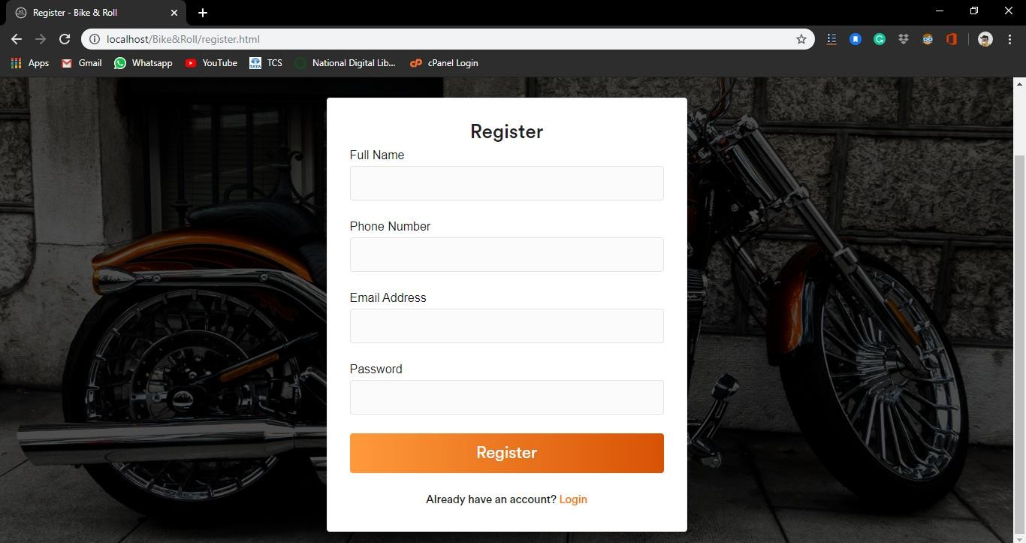

**Fig 6.2**: Registration Page

Fig. 6.3 the login page displayed when existing user wants to login.

**Fig 6.3:** Login Page

This is the page which provides an interface for the user to use the functionalities - Fig 6.4

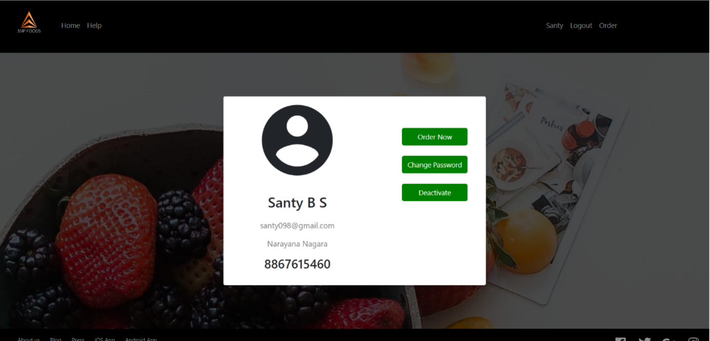

**Fig 6.4:** How it Works page

This is the page which displays the list of hotels available, as shown in the Fig. 6.5



**Fig 6.5:** Hotel List Page

This is the page which displays the menu of the selected hotel, as shown in the Fig. 6.6

**Fig 6.6:** Hotel Menu Page

This page displays the checkout details, the amount payable by the user including taxes and delivery charges, shown in the Fig. 6.7

**Fig 6.7**: Checkout Page

This page displays the interface provided for the user to change his password, shown in the below Fig. 6.8

**Fig 6.8:** Change password Page

This is the page which allows the user to delete his/her account, as shown in the Fig. 6.9

**Fig 6.9:** Delete Account page.

This is the page which displays the frequently asked questions, as shown in the Fig. 6.10

**Fig 6.10:** Help and FAQ page.

**CHAPTER 7**

**CONCLUSION**

An attempt has been made to develop HTML web pages and backend database management system which meets necessary requirements of the user successfully. Since it is user-friendly, it enables the user to interact efficiently and easily.

The application **Food Ordering Dashboard** would be helpful in automating the existing manual system, which is very much essential for an efficient management of massive data. This mini project is very useful for the restaurant executives for a computerized and efficient management of their services.

The mini project has been implemented with a simple interface so that the user can use it without the thorough knowledge of HTML or SQL.

This mini project has been demonstrated to fulfil the requirements. The functionality of all the modules and the module level integration is found to be satisfactory.

The development of the mini project has given us a good exposure to HTML, CSS, JavaScript, jQuery, PHP and SQL by which we have learnt some of the technique which helps in the development of web applications.

Hence it is helpful for us even to take up this field as our career too and develop some other features in front-end as well as back-end and provide as a token of contribution to the internet world.

**CHAPTER 8**

**FUTURE ENHANCEMENTS**

The mini project **Food Ordering Dashboard** has a few limitations but it has a lot of future scope and features that could be added to make it more widely acceptable. One of the major enhancements which can be made to the mini project is to host the platform on online servers to make is accessible worldwide. The mini project shall include a master-slave database structure to reduce overload on databases on regular basis on different servers. The mini project can also integrate animations in the front-end to improve the user experience. The project can be implemented with Google APIs to automatically detect users’ location and display the nearby restaurants.

Other enhancements that can be made by including multiple load balancers to distribute loads on system and also incorporating customers’ reviews and ratings. The mini project can also include an automated chatbot to provide solutions to the customers’ queries.

**CHAPTER 9**

**REFERENCES**

[1] Randy Connolly, Ricardo Hoar, "Fundamentals of Web Development”, 1st Edition, Pearson Education India.

[2] Robin Nixon, “Learning PHP, MySQL &JavaScript with jQuery, CSS and HTML5”,

4th Edition, O‟Reilly Publications, 2015.

[3] Luke Welling, Laura Thomson, “PHP and MySQL Web Development”, 5th Edition, Pearson Education, 2016.

[4] w3schools.com

[Courtesy: https://www.w3schools.com/howto/howto_website.asp] [5] w3schools.com

[Courtesy: https://www.w3schools.com/css/css_website_layout.asp] [6] w3schools.com

[Courtesy: https://www.w3schools.com/php/]